JENKINS ARTICLE -3

TASK-1 Running Stages in Parallel With Jenkins Workflow / Pipeline

1. Overview
Jenkins is a popular open-source automation server that facilitates CI/CD processes through its workflow or pipeline feature. In software development, continuous integration and continuous delivery have become standard practices to ensure that code changes are thoroughly tested and automatically deployed to production environments.
Running stages in parallel with Jenkins Workflow/Pipeline is a technique that allows developers to execute multiple stages simultaneously, which can improve the overall performance and speed of the development process.
In this tutorial, we’ll explore how to run stages in parallel with a Jenkins workflow or pipeline job.

2. Understanding Jenkins Workflow/Pipeline
Jenkins Workflow or Pipeline is a powerful feature that allows us to define the build, test, and deployment of the code. Each step in the software development life cycle is represented by a stage in a pipeline job. A stage can consist of multiple sequential steps or tasks.
We can use stages to build, test, and deploy software applications automatically. Developers use stages in Jenkins Workflow/Pipeline to define the sequence of tasks that can execute as part of the software development process.

3. Understanding the Stages in Jenkins Workflow/Pipeline
In Jenkins Workflow/Pipeline, stages represent a distinct phase in the software development process. Each stage has a specific function, such as compiling code, running tests, or deploying code. The process ensures that code changes are thoroughly tested and integrated into the main branch quickly and frequently. Additionally, this approach helps developers to catch errors early and release software applications more reliably and faster.
Typically, there are three different types of stages in a Jenkins pipeline job:
- A sequential stage executes the stages in order, starting with the first stage and continuing with the second stage
- Parallel stages execute simultaneously and independently of each other, meaning that multiple stages can complete simultaneously
- Conditional stages are the one that executes on a specific condition, like passing or failing a test
Furthermore, these stages are designed to help streamline processes and improve efficiency by breaking them down into smaller, more manageable parts that can be executed in a structured and organized manner.

4. Running Stages in Parallel
In some cases, we might want to speed up our pipeline by running multiple stages in parallel. We might have a stage that builds our application and another that runs automated tests. These stages can be run in parallel because the tests don’t depend on the completed build. Furthermore, we need to define a parallel block to run stages in parallel with Jenkins Workflow or Pipeline.

4.1. Parallel Blocks in JenkinsFile
The parallel block is a section of code that defines multiple stages to run in parallel. Let’s look at a pipeline job with a parallel block:
PARLLEL STAGES :

pipeline {
agent any
stages {
stage('Build') {
steps {
sh 'echo "Building the application"'
// Add commands to build application
}
}
stage('Test') {
parallel {
stage('Unit Tests') {
steps {
sh 'sleep 5s'
sh 'echo "Running unit tests"'
// Add commands to run unit tests
}
}
stage('Integration Tests') {
steps {
sh 'echo "Running integration tests"'
// Add commands to run integration tests
}
}
}
}
stage('Deploy') {
steps {
sh 'echo "Deploying the application"'
// Add commands to deploy application
}
}
}
}
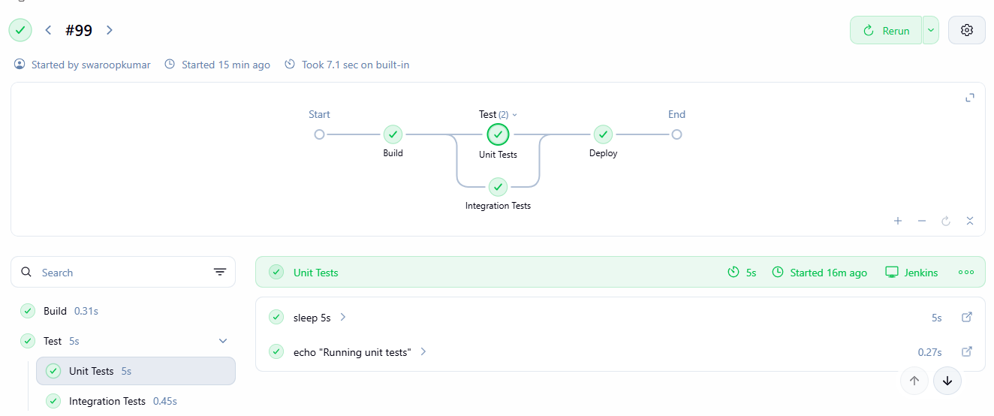
In the pipeline job above, we have three stages: build, test, and deploy. In this pipeline job, we have added simple steps to each stage to demonstrate the execution and workflow of a pipeline. The build stage is responsible for building the application code. To illustrate, there is only one step in the build stage, which is an echo command that prints the message “Building the application” to the console. This stage can have additional commands to build the code.
The test stage has a parallel block that defines two stages to run in parallel: Unit Tests and Integration Tests. The parallel directive allows both stages to run at the same time. Therefore, in this stage, we can’t be certain which stage will complete its task first. In the “Unit Tests” stage, the script first sleeps 5 seconds using the sleep command before executing an echo command to print “Running unit tests” to the console. Then, it runs commands to execute unit tests. In the “Integration Tests” stage, the script executes commands to run integration tests.
Finally, the Deploy stage is responsible for deploying the application code. Inside this stage, there is only one step, which is an echo command that prints the message “Deploying the application” to the console.

CONDITIONAL STAGES :
pipeline {
agent any

stages {

stage('Git Checkout') {
steps {
git branch: 'main',
url: 'https://github.com/betawins/hiring-app.git'
}
}

stage('Build') {
steps {
echo 'Building the application...'
}
}

stage('Test') {
steps {
echo 'Running tests...'
sh 'mvn test'
}
}

stage('Deploy') {
when {
expression {
currentBuild.currentResult == 'SUCCESS'
}
}
steps {
echo 'Tests passed. Deploying application...'
}
}
}
}
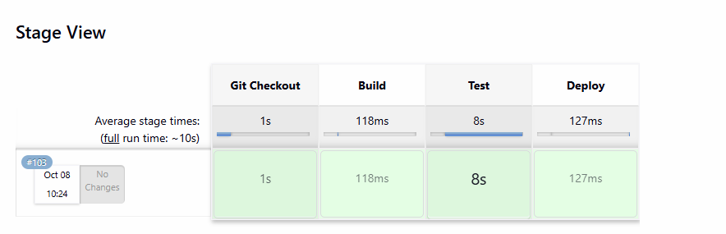

5. Benefits of Running Stages in Parallel
Running stages in parallel has several advantages for developers. It reduces the development process duration, which leads to faster execution. Furthermore, developers can also complete more work in less time with this feature.
Running parallel stages can accelerate the detection of errors and bugs, rendering software applications more reliable. By utilizing parallel stages, developers can enjoy these benefits and produce high-quality software applications efficiently.

6. Conclusion
In this article, we explored how to run multiple stages in parallel with a Jenkins workflow or pipeline job. First, we looked at the basic concepts and execution of the Jenkins pipeline job and its stages. After that, we ran multiple parallel stages in a Jenkins pipeline job. Finally, we also explored the benefits of running stages in parallel.
We can also find scripts to run multiple stages in parallel over on GitHub.

TASK-2 Get the Output of a Shell Command in a Jenkins Pipeline

1. Overview
Jenkins pipeline is a powerful tool used to automate software development processes. Developers use it to build, test, distribute, publish, and deploy software. In addition to this, the Jenkins pipeline permits developers to create a repeatable and scalable process that can be easily modified as their software development needs change.
In this tutorial, we’ll discuss how to get the output of a shell command executed in the pipeline.

2. Importance of Capturing Output
The shell command is a powerful feature of the Jenkins pipeline that allows developers to execute shell scripts within their pipeline script. The Jenkins agent executes shell commands and prints output to the Jenkins console. A Jenkins pipeline uses variables to store data for access and modification throughout the script.
We can define variables either at the top of the pipeline script or within a stage block. Capturing the output of a shell command into a variable is important as it permits developers to use the output of one shell command as input for another. Hence, developers can use the pipeline script to store the output of a shell command.

3. Using the sh returnstdout
The sh step command is a built-in Jenkins pipeline step that allows developers to execute a shell command and capture its output into a variable. Using shell commands, we can assign variables to strings. In a Jenkins pipeline, we can use the sh step to execute a shell command within a pipeline. Let’s look at a pipeline job to execute a command and store its output:
pipeline {
agent any
stages {
stage('Example') {
steps {
script {
def output = sh(returnStdout: true, script: 'pwd')
echo "Output: ${output}"
}
}
}
}
}
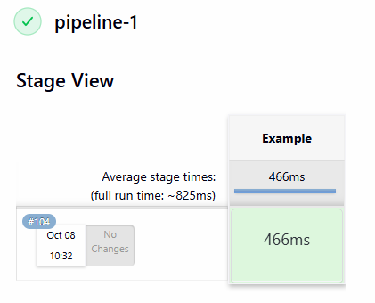
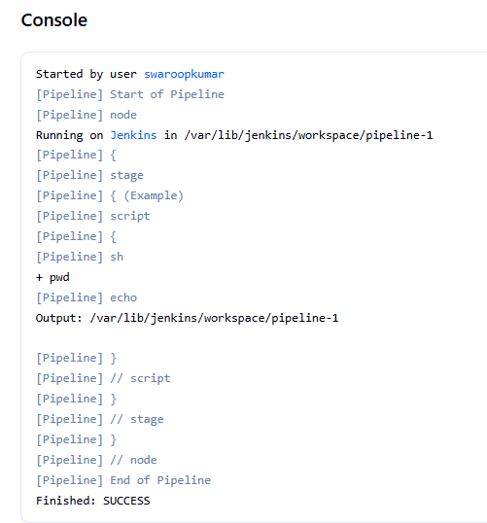
The pipeline job above defines a stage “Example” along with its steps to execute, including the script element. This special step enables the execution of arbitrary Groovy code within the pipeline. Also, it is utilized to define a Groovy closure that captures shell output. Here, we performed the pwd command inside the script element of the pipeline using the sh returnStdout method. Also, we stored the result in the output variable. The option “returnStdout: true” instructs Jenkins to return the standard output of the shell command. The option “script: ‘pwd'” specifies the shell command to execute.
Finally, the echo command prints the value of the “output” variable to the Jenkins console using the echo step.

4. Using Command Substitution
Command substitution is a shell feature that allows developers to execute a command within a string and use its output as part of the string. In the Jenkins pipeline, we can use command substitution to capture the output of a shell command into a variable:

pipeline {
agent any
stages {
stage('Example') {
steps {
script {
def output = sh(script: "echo \$(ls)", returnStdout: true)
echo "Output: ${output}"
}
}
}
}
}
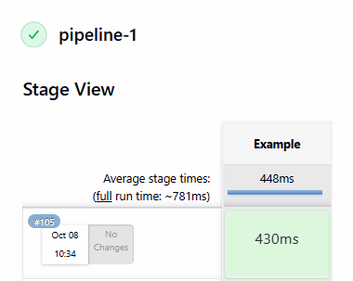

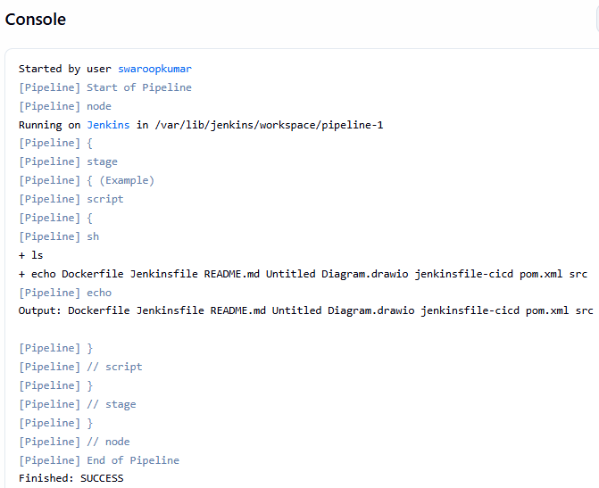
In this case, the sh step executes the command “echo $(ls)” and captures its output into a variable using command substitution. Furthermore, the pipeline job captures the output of the “ls” command into the “output” variable and prints it to the Jenkins console upon execution.

5. Other Possible Cases
Jenkins pipeline provides two other important options which are very useful in storing the result to further use in the pipeline job. The returnStatus method captures the exit status of a shell command, whereas returnStdoutTrim is helpful in trimming the output for further use.

5.1. Using the returnStatus
The Jenkins pipeline’s sh step uses the returnStatus option to capture the exit status of a shell command. By default, the sh step returns the standard output of the shell command as the result of the step. However, when returnStatus is set to true, the exit status of the shell command is returned instead of the standard output.
Let’s look at the pipeline job with returnStatus method:
pipeline {
agent any
stages {
stage('Example') {
steps {
script {
def status = sh(returnStatus: true, script: 'ls /test')
if (status != 0) {
echo "Error: Command exited with status ${status}"
} else {
echo "Command executed successfully"
}
}
}
}
}
}
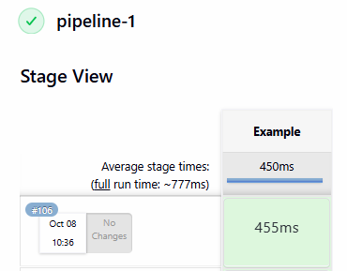
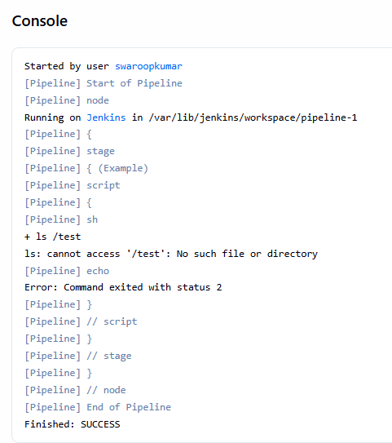
In this example, the sh step executes the ls command and captures the output into the status variable using returnStatus. Since the directory /test doesn’t exist, the ls command will exit with a non-zero status, indicating an error. The if statement checks if the status variable is non-zero, and if so, prints an error message to the Jenkins console.
Developers can perform error checking by capturing the exit status of shell commands. Furthermore, they can also implement logic based on the success or failure of a command.

5.2. Using the Trim Method
In the following snippet The returnStdout parameter is set to true, which means that the standard output of the command will be captured and returned as the result of the step. Additionally, we can also use the trim() method to get the cleansed output of the command in a variable:
pipeline {
agent any
stages {
stage('Example') {
steps {
script {
def output = sh(returnStdout: true, script: 'echo " hello "').trim()
echo "Output: '${output}'"
}
}
}
}
}
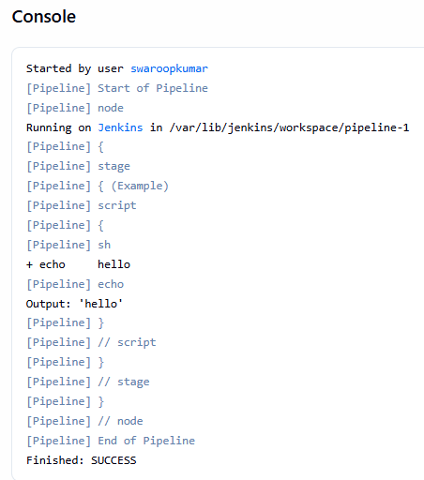

The trim() method will remove any leading and trailing whitespace characters from the output of the echo command. Furthermore, the Jenkins console will display the resulting output enclosed in single quotes to highlight any whitespace characters.

6. Conclusion
In this article, we discussed two different methods for capturing the output of a shell command executed in the Jenkins pipeline into a variable.
First, we looked into capturing the output using sh returnStdout. After that, we explored the same using command substitution. Both methods can capture the output of a shell command. Despite this, the returnStdout method of sh is easier to read and simpler than command substitution.
TASK-3 Jenkins Pipeline – Change to Another Folder

1. Overview
Jenkins pipeline automates a project’s entire CI/CD process using Jenkinsfile. A wide range of applications can be built, tested, and deployed using the pipeline. In addition, whenever code changes, the Jenkins pipeline can automatically run, saving time and reducing errors.
In Jenkins, sometimes we need to run a series of actions at a specific location on the file system. Thus, in such cases, we can change the working directory using the “dir” or “sh” steps.
In this tutorial, we’ll look at how to change the working directory in a Jenkins pipeline.

2. Using the dir Step
There are several ways to change the working directory of Jenkins pipelines. The dir step is a built-in step in Jenkins that allows us to change to a different directory for the duration of a block. This is very useful when we want to run specific commands from a particular directory.
Let’s look at the dir step to change our current working directory to a subdirectory “scripts”:
pipeline {
agent any
stages {
stage('Build') {
steps {
dir('scripts') {
/* execute commands in the scripts directory */
}
}
}
}
}

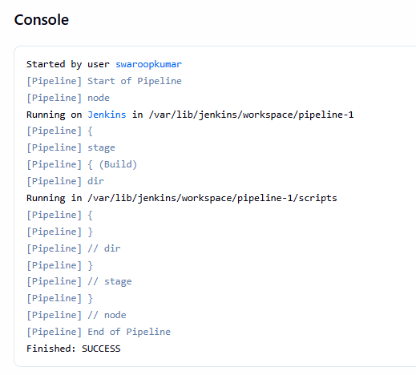

We defined a Build stage in our pipeline that changes the working directory. Using the dir function, the script switches to the directory “scripts”, then runs the build steps. In addition, we used “any” agent in the above script, which means that any available Jenkins agent can execute this pipeline job. As soon as the block ends, the working directory will return to its previous state.
Additionally, we can change to any directory using this method, not just subdirectories. In order to change directories outside of the current working directory, we need to provide the absolute path:
pipeline {
agent any
stages {
stage('Build') {
steps {
dir('/var/jenkins_home/workspace/SamplePipeline/scripts') {
/* execute commands in the scripts directory */
}
}
}
}
}

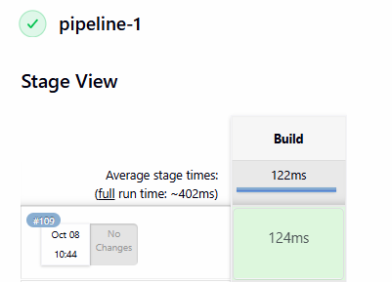
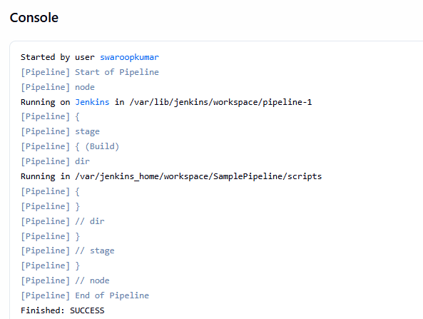
In the above case, we’ve successfully changed the working directory to /var/jenkins_home/workspace/SamplePipeline/scripts.

3. Using the sh Step
Another way to change directories in a Jenkins pipeline is to use the sh step with the cd command. Using the sh step, we can change our working directory to the scripts directory:
pipeline {
agent any

stages {

stage('Git Checkout') {
steps {
git branch: 'main',
url: 'https://github.com/betawins/hiring-app.git'
}
}

stage('Build') {
steps {
echo 'Building the application...'
sh 'mvn clean package'
}
}

stage('Test') {
steps {
echo 'Running tests...'
sh 'mvn test'
}
}

stage('Deploy') {
when {
expression {
currentBuild.currentResult == 'SUCCESS'
}
}
steps {
echo 'Tests passed. Deploying application...'
}
}
}
}
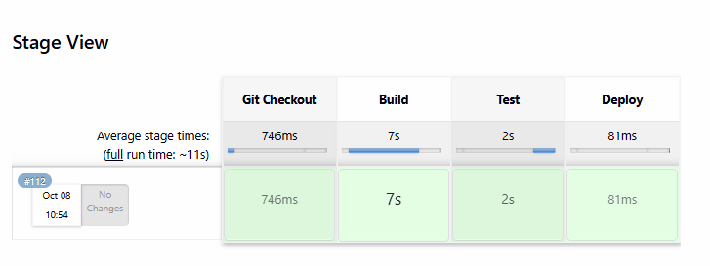
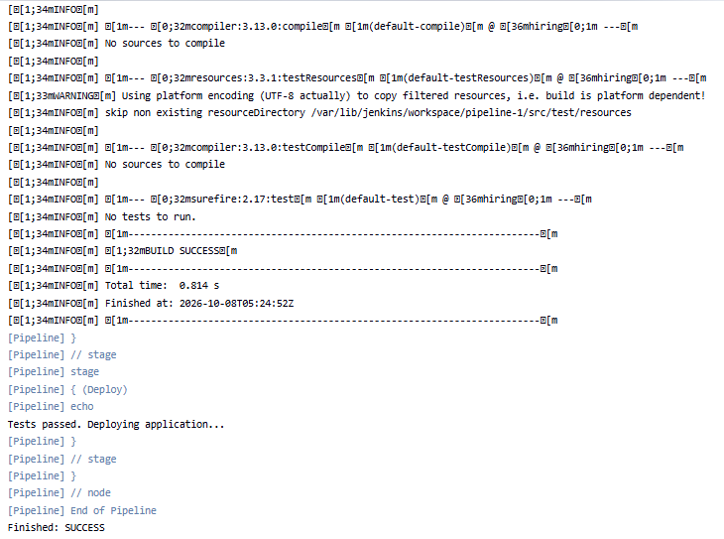

In this case, the sh step uses the cd command to change the current working directory to “scripts”. The sh step allows us to execute shell commands in a pipeline. As soon as the working directory is changed, the pipeline runs the build steps within the “scripts” directory.

4. Conclusion
In this article, we learned how to change the working directory in a Jenkins pipeline. First, we looked at changing the directory using the dir step. After that, we explored the same using the cd command with the sh step.
We can find the script for the directory change pipeline over on GitHub.

TASK-4 Fixing the “No Such DSL method” Error in Jenkins Pipeline

1. Overview
Jenkins is an automation tool that helps developers with software development cycles. Additionally, Jenkins can automate the testing and deployment of applications using pipelines. Sometimes, while using Jenkins pipelines, we may encounter the “No such DSL method” error. Jenkins throws this error when it doesn’t recognize the method or syntax we used in our Jenkinsfile.
In this tutorial, we’ll explore all the cases of the “No such DSL method” error and its possible solutions.

2. Typo Error
One common cause of this error is a typo in our Jenkinsfile. If we type a method or syntax incorrectly, Jenkins won’t be able to recognize it and will throw the “No such DSL method” error. To illustrate, let’s look at an example of getting the “No such DSL method” error:
pipeline {
agent any
stages {
stage('Build') {
steps {
mvn 'clean instal'
}
}
}
}
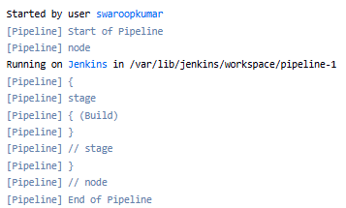

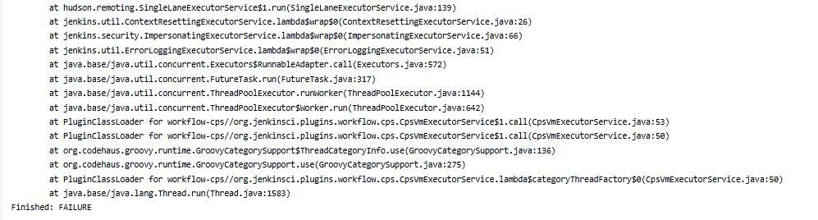
As in the above script, we can see we’ve made a typo error in the mvn command “mvn clean instal”. In order to fix this error, we just need to fix the typo in the Maven command:
pipeline {
agent any
stages {
stage('Build') {
steps {
mvn 'clean install'
}
}
}
}
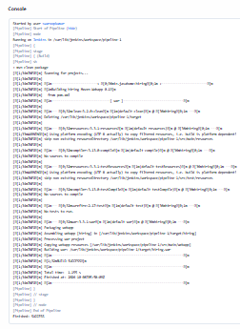
In this case, we can see the issue resolved with the typo correction. Moreover, we should always double-check the syntax and method names in our Jenkinsfile.

3. Other Possible Reasons
The Jenkins Pipeline is constantly evolving, and the new Jenkins versions bring new methods and functions. We can face this problem when some of the methods and functions in the script are no longer supported on newer versions. To resolve this error, we can check the spelling of the method name. In addition, we can check the documentation of the Jenkins Pipeline DSL to verify if the method called is a valid method. Also, make sure that the necessary plugin is installed.

3.1. Missing Dependency
The Jenkins Pipeline provides various methods and syntax that require additional dependencies and plugins. We face this “No such DSL method” error if a method or syntax is required in the script and its dependency isn’t available. However, this issue can be resolved by installing the appropriate plugin or library.

3.2. Outdated Jenkins Version
The outdated version of Jenkins can also cause the “No such DSL method” error. However, we can resolve this error by upgrading Jenkins to the latest version. Upgrading Jenkins will also give us access to the latest features and improvements in the Jenkins Pipeline DSL.

3.3. Outdated Syntax
The Jenkins Pipeline DSL is widely used, and old syntax may no longer be supported. If we use an old version of the Jenkinsfile, we may encounter the “No such DSL method” error. To fix this issue, update the Jenkinsfile and use the latest syntax.
As a last resort, we can run the Jenkinsfile with the -X flag, which will enable debugging output. In this way, we’ll be able to gain more insight into the error and identify the root cause.

4. Conclusion
In this article, we’ve learned how to fix the “No such DSL method” error in Jenkins Pipeline. First, we looked at the causes of the error. After that, we provided possible solutions to it.
In short, we explored both the causes and solutions to the “No such DSL method” error in the Jenkins pipeline.
We can find the script for the typo fix pipeline over on GitHub.

TASK-5 Trigger Another Job from a Jenkins Pipeline

1. Overview
Jenkins is an automation server that provides developers with the ability to build, test, and deploy applications automatically. The Jenkins server executes jobs, which can be triggered manually or automatically. Also, we can run these jobs simultaneously or in a specific order.
In this tutorial, we’ll walk through the process of creating a freestyle job and a pipeline job to trigger another job.

2. Job Setup
In Jenkins, we can create jobs to run code coverage tests, integration tests, and deploy applications. To execute a set of tasks, Jenkins provides different types of jobs. Furthermore, depending on the task, we may have to trigger an internal job.
Here, we’ll build two jobs, a parent pipeline job, and a child freestyle job. We’ll run the parent job manually from the Jenkins UI, whereas the child job will be triggered internally by the parent job.
Let’s look at the child’s job first.

2.1. Create a Freestyle Child Job
Before we start, let’s build a demo setup first. We’ll use the freestyle job type for creating the child job. The freestyle build jobs are easy to use and have many pre-made options. Furthermore, to create a freestyle job, we need to follow these steps:
- Click on New Item in the Jenkins dashboard
- Set a “Job Name” as childJob
- Select the “Job Type” as “Freestyle project”
- Add echo “childJob” command in the execute shell of the build step
- Save the job
Everything should look similar to this:
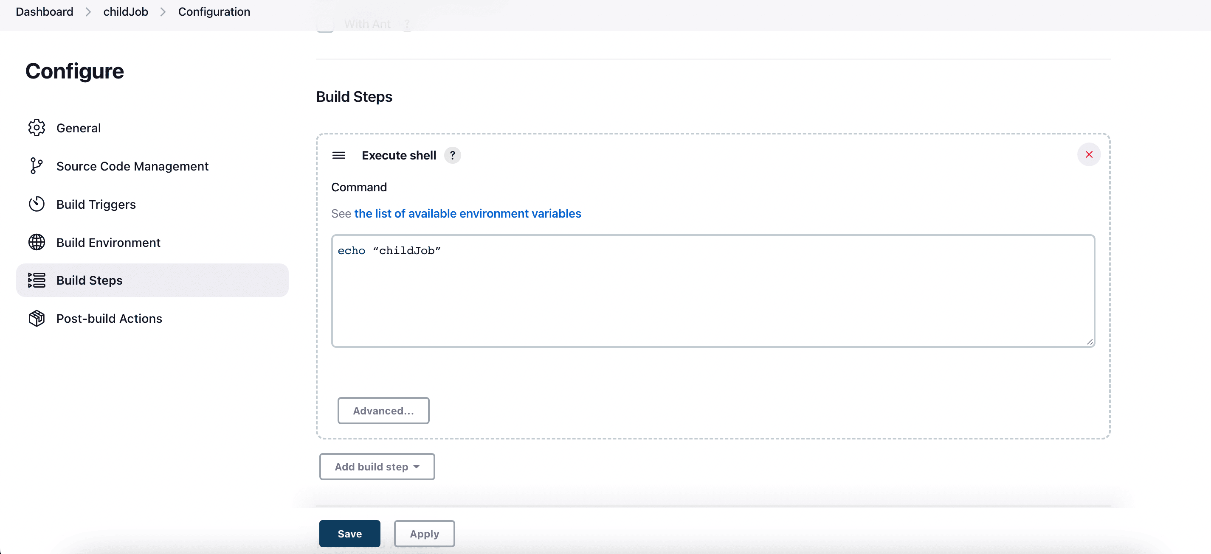
As a result of the above steps, we are now able to create a simple freestyle job that can run independently or can be triggered by another job.
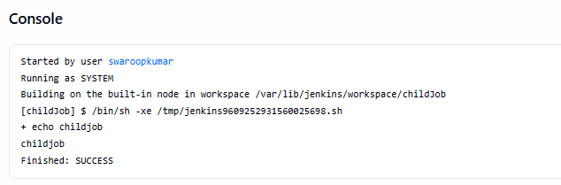

2.2. Create a Pipeline Parent Job
A Jenkins pipeline is a series of interrelated events or jobs that produce continuous delivery in our software development workflow. Here, we will create a pipeline job that will internally call the childJob we just created. Let’s look at the Groovy script for the pipeline job:
pipeline {
agent any
stages {
stage('build') {
steps {
echo "parentJob"
}
}
stage('triggerChildJob') {
steps {
build job: "childJob", wait: true
}
}
}
}
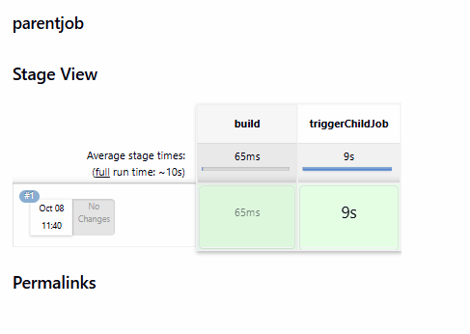
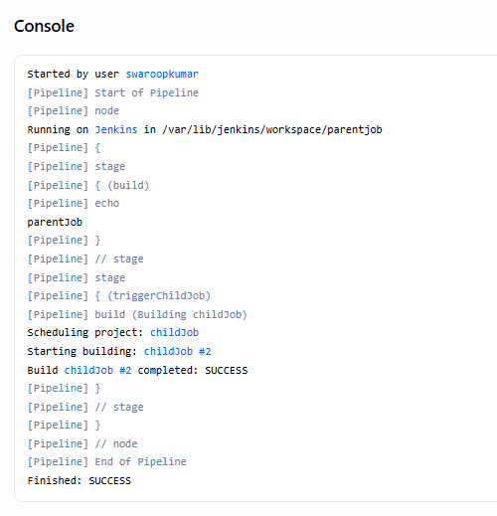
The above script contains two stages, build and triggerChildJob, in the pipeline job. The first stage simply executes the echo command, while the second stage will trigger the childJob internally.
Let’s now create a pipeline job using the above Groovy script:
- Click on New Item in the Jenkins dashboard
- Set the “Job Name” as parentJob
- Select the “Job Type” as Pipeline project
- Add the Groovy script as explained above and save the job
As a result:

We can now trigger a freestyle job from a Jenkins pipeline job. Note that the parent job build will take place in stages, as shown in the image below:
Here in the above output, we can see both stages build, and triggerChildJob ran successfully.

3. Conclusion
In this article, we demonstrated how to create a job that internally triggers another job in Jenkins. As a first step, we created a sample freestyle Jenkins job and then created a pipeline job to internally trigger it.
We can find the script of the pipeline job over on GitHub.

TASK-6 How to Inject Git Secrets in Jenkins
1. Introduction
Jenkins is an excellent tool for automating software builds and deliveries, especially when using git for software configuration management. However, a common problem when using Jenkins is how to handle sensitive data such as passwords or tokens.
In this tutorial, we’ll look at how to securely inject git secrets into Jenkins pipelines and jobs.
2. Git Secrets
To get started, we’ll first look at generating git secrets.
2.1. Create GPG Keys
Because git secrets use GPG keys, we must first ensure we have a valid key to use:
$ gpg --gen-key
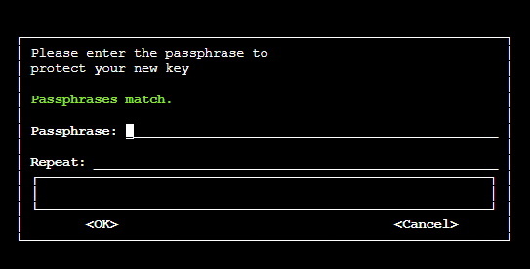
This will create a public and private key pair in our home directory, which is sufficient to start creating secrets. Later, we’ll see how to export the key for use with Jenkins.

2.2. Initialize Secrets
The git-secret utility is an add-on to git that can store sensitive data inside a git repository. Not only is it a secure way to store credentials, but we also get the benefits of versioning and access control that is native to git.
To get started, we must first install the git-secret utility. Note that this is not a part of most git distributions and must be installed separately.
Once installed, we can initialize secrets inside any git repository:
$ git secret init
This is similar to the git init command. It creates a new .gitsecret directory inside the repository.
As a best practice, we should add all files in the .gitignore directory to source control, except for the random_seed file. The init command above should ensure our .gitignore handles this for us, but it’s worth double-checking.
Next, we need to add a user to the git secret repo keyring:
$ git secret tell mike@aol.com
We are now ready to store secrets in our repo.

2.3. Storing and Retrieving Secrets
The git secret command works by encrypting specific files in the repo. The files are given a .secret extension, and the original filename is added to .gitignore to prevent it from being committed to the repository.
As an example, let’s say we want to store a password for our database inside a file named dbpassword.txt. We first create the file:
$ echo "Password123" > dbpassword.txtCopy
Now we encrypt the file:
$ git secret add dbpassword.txt
Finally, we must commit the secret using the hide command:
$ git secret hide
At this point, we should commit our changes to ensure the file is securely stored inside our repo. This is done using standard git commands:
$ git add .
$ git commit -m "Add encrypted DB password"
$ git push
Note that the unencrypted file is still available locally. However, it has automatically been ignored by git, so we cannot accidentally check it in.
To confirm this, if we were to do another checkout of the repository, this is what we would see:
$ ls
dbpassword.txt.secretCopy
Note that the contents of the .secret file are encrypted and unreadable. Before we can read them, we have to decrypt the file:
$ git secret reveal -p <PASSPHRASE>
$ git secret cat dbpassword.txtCopy
PASSPHRASE is the GPG passphrase we used when generating our GPG key.

3. Using Git Secrets With Jenkins
We have now seen the steps required for storing and retrieving credentials using git secret. Next, we’ll see how to use encrypted secrets with Jenkins.

3.1. Create Credentials
To get started, we must first export the GPG private key we generated earlier:
$ gpg -a --export-secret-keys mike@aol.com > gpg-secret.key
$ gpg --export-ownertrust > gpg-ownertrust.txtCopy
It’s important to keep this private key safe. Never share it or save it to a publicly accessible location.
Next, we need to store this private key inside Jenkins. We’ll do this by creating multiple Jenkins credentials to store the GPG private key and trust store we just exported.
First, navigate to Credentials > System > Global Credentials and click Add Credentials. We need to set the following fields:
- Kind: Secret file
- File: Upload the gpg-secret.key we exported above
- ID: gpg-secret
- Description: GPG Secret Key

Save the credential, and create another one for the trust store file:
- Kind: Secret file
- File: Upload the gpg-ownertrust.txt we exported above
- ID: gpg-ownertrust
- Description: GPG Owner Trust

Save the credential and create a final credential for the GPG passphrase:
- Kind: Secret text
- Text: <Passphrase used to generate GPG key>
- ID: gpg-passphrase
- Description: GPG Passphrase
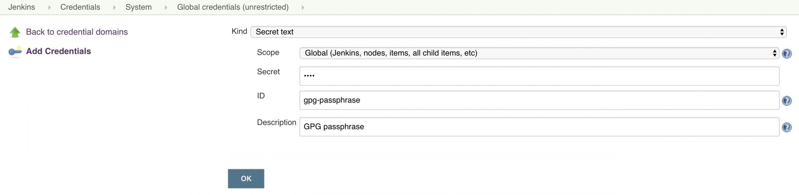

3.2. Use Credentials in Pipeline
Now that we have the GPG key available as credentials, we can create or modify a Jenkins pipeline to use the key. Keep in mind that we must have the git-secret tool installed on the Jenkins agent before this will work.
To access the encrypted data inside our pipeline, we have to add a few pieces to the pipeline script.
First, we add an environment declaration:
environment {
gpg_secret = credentials("gpg-secret")
gpg_trust = credentials("gpg-ownertrust")
gpg_passphrase = credentials("gpg-passphrase")
}
This makes the three credentials we created earlier accessible to subsequent pipeline stages.
Next, we import the GPG key and trust into the local agent environment:
steps {
sh """
gpg --batch --import $gpg_secret
gpg --import-ownertrust $gpg_trust
"""
}
Finally, we can perform git secret commands inside the repo:
steps {
sh """
cd $WORKSPACE
git secret reveal -p '$gpg_passphrase'
git secret cat dbpassword.txt
"""
}
When we execute the pipeline, we should see the database password output at the end:
+ git secret cat dbpassword.txt
Password123Copy

3.3. Jenkins Jobs
We can also use git secrets using traditional Jenkins jobs.
Just like with pipelines, we must configure 3 Jenkins credentials for our GPG key, trust, and passphrase.
The main difference from pipelines is that we inject the GPG credentials using the Jenkins environment configuration panel:
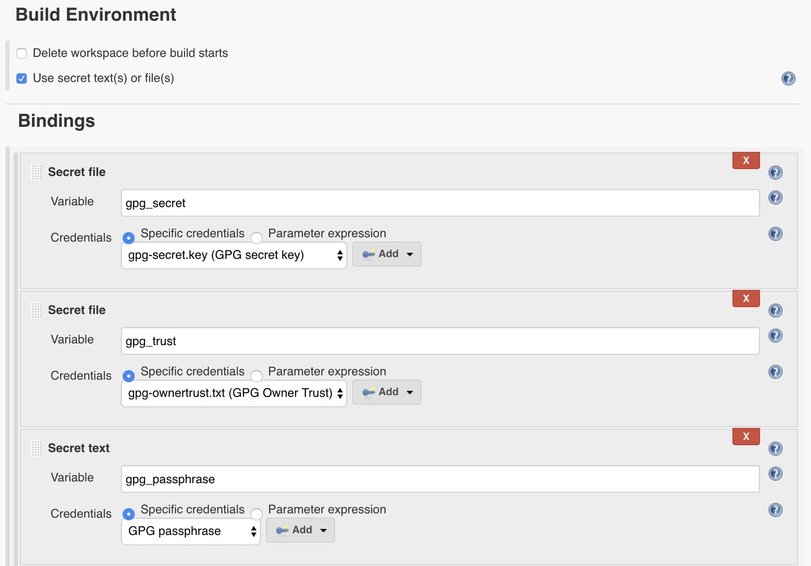
Then we can add the GPG import and git secret commands into shell commands:
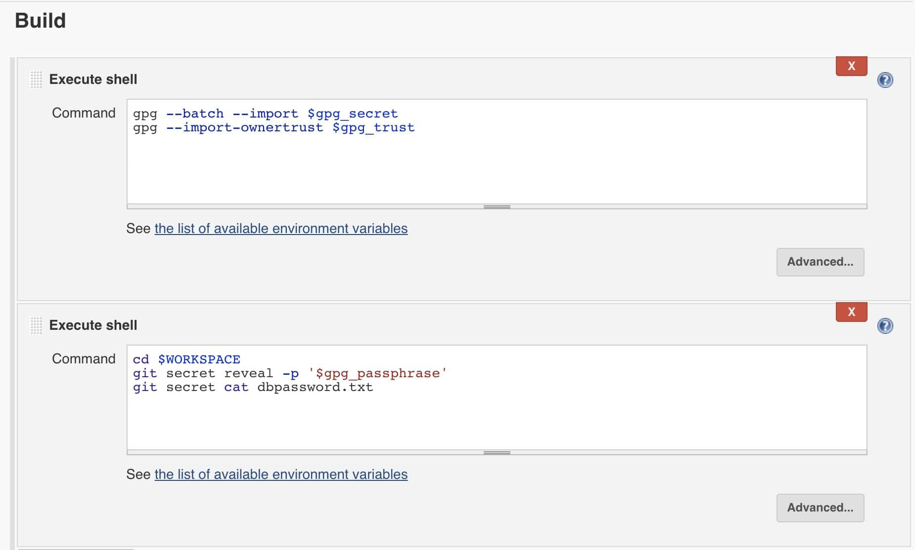
As with the pipeline, we should see the database password printed at the end of the job execution:
+ git secret cat dbpassword.txt
Password123
Finished: SUCCESS

4. Conclusion
In this tutorial, we have seen how to use git secrets with both Jenkins pipelines and traditional jobs. This is an easy way to provide access to sensitive data to your CI/CD pipelines.
However, note that, while Git secrets is one option for storing keys, other dedicated security solutions like Hashicorp Vault offer stronger alternatives.

This will prompt us for a full name and email, as well as a secret passphrase. Remember this passphrase, as we will need it later when we configure Jenkins.

TASK-7 Scripted vs Declarative Pipelines in Jenkins

1. Overview
“Pipeline-as-code” is the idea to allow everyone involved in DevOps to create and maintain Jenkins pipelines. In fact, there are two ways of applying this “pipeline-as-code” principle in life: Scripted and Declarative pipelines. “Pipeline-as-code” allows Jenkins to treat pipelines as regular files. People involved in DevOps can store, share, and also can use those files with SCM.

2. Declarative Pipelines and Their Benefits
Declarative pipelines are a more recent approach to the “pipeline-as-code” principle. They are quite easy to write and understand. The structure may seem to be a bit complex, but overall, it contains only a couple of basic sections. The “pipeline” block is the main block that contains the entire declaration of a pipeline. In this example, we’ll consider only “agent”, “stages”, and “steps” sections:
- pipeline – contains the whole pipeline

  - agent – defines the machine that will handle this pipeline
  - stages – declares the stages of the pipeline
    - steps – small operations inside a particular stage
Let’s check what this structure will look like in our declarative pipeline:
pipeline {
agent any
stages {
stage('Hello World') {
steps {
sh 'echo Hello World'
}
}
}
}

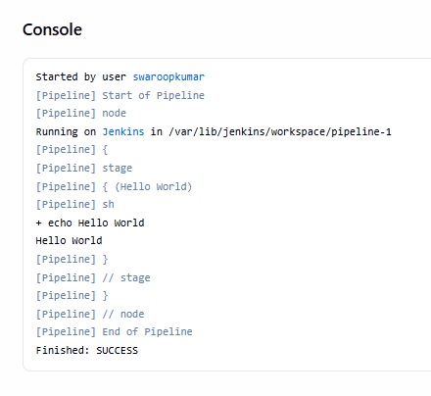
Another important part of declarative pipelines is directives. In fact, directives are a convenient way to include additional logic. They can help to include tools into a pipeline and can also help with setting triggers, environment variables, and parameters. Some directives can prompt users to input additional information. There’s an easy-to-use generator that can help with creating these directives.
In the previous example, “steps” is a directive that contains the logic that will be executed in the stage. There’s a dedicated snippet generator that provides a convenient way of creating steps.
The power of declarative pipelines comes mostly from directives. Declarative pipelines can leverage the power of scripted pipelines by using the “script” directive. This directive will execute the lines inside as a scripted pipeline.

3. Scripted Pipelines and Their Benefits
Scripted pipelines were the first version of the “pipeline-as-code” principle. They were designed as a DSL build with Groovy and provide an outstanding level of power and flexibility. However, this also requires some basic knowledge of Groovy, which sometimes isn’t desirable.
These kinds of pipelines have fewer restrictions on the structure. Also, they have only two basic blocks: “node” and “stage”. A “node” block specifies the machine that executes a particular pipeline, whereas the “stage” blocks are used to group steps that, when taken together, represent a separate operation. The lack of additional rules and blocks makes these pipelines quite simple to understand:
node {
stage('Hello world') {
sh 'echo Hello World'
}
}
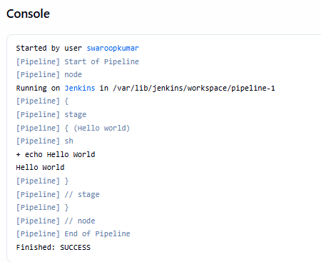
Think about scripted pipelines as declarative pipelines but only with stages. The “node” block in this case plays the role of both the “pipeline” block and the “agent” directive from declarative pipelines.
As mentioned above, steps for the scripted pipelines can be generated with the same snippet generator. Because this type of pipeline doesn’t contain directives, steps contain all the logic. For very simple pipelines, this can reduce the overall code.
However, it may require additional code for some boilerplate setups, which can be resolved with directives. More complex logic in such pipelines is usually implemented in Groovy.

4. Comparison of Scripted and Declarative Pipelines
Let’s check a three-step pipeline that pulls a project from git, then tests, packages, and deploys it:
pipeline {
agent any
tools {
maven 'maven'
}
stages {
stage('Test') {
steps {
git 'https://github.com/user/project.git'
sh 'mvn test'
archiveArtifacts artifacts: 'target/surefire-reports/**'
}
}
stage('Build') {
steps {
sh 'mvn clean package -DskipTests'
archiveArtifacts artifacts: 'target/*.jar'
}
}
stage('Deploy') {
steps {
sh 'echo Deploy'
}
}
}
}
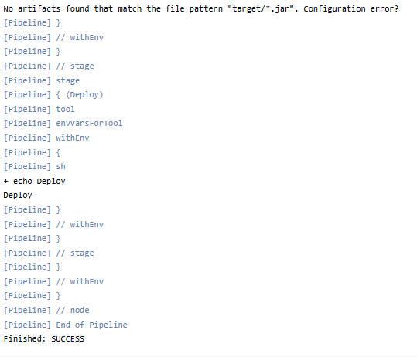
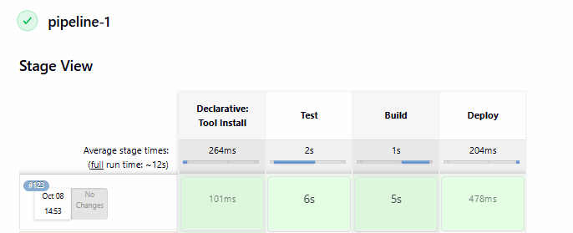
As we can see, all logic resides inside the “steps” sections. Thus, if we would like to translate this declarative pipeline to a scripted pipeline, those parts would not be changed:
node {
stage('Test') {
git 'https://github.com/user/project.git'
sh 'mvn test'
archiveArtifacts artifacts: 'target/surefire-reports/**'
}
stage('Build') {
sh 'mvn clean package -DskipTests'
archiveArtifacts artifacts: 'target/*.jar'
}
stage('Deploy') {
sh 'echo Deploy'
}
}
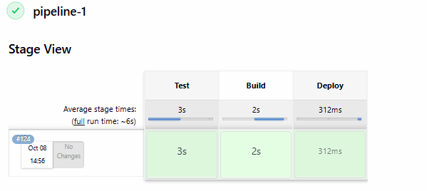
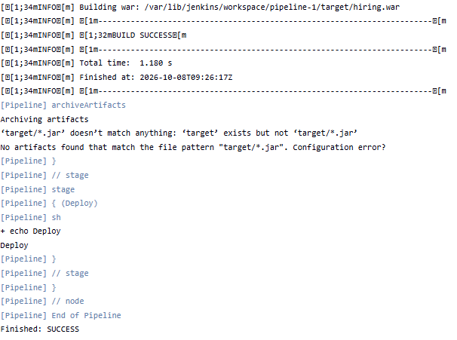
A scripted pipeline for the same functionality looks denser than its declarative counterpart. However, we should ensure that all the environment variables are set correctly on the server. At the same time, if there are several Maven versions, we’ll need to change them directly in the pipeline. For this, we can use a concrete path directly or an environment variable.
There’s also a “withEnv” step that can be useful in scripted pipelines. With declarative pipelines, on the other hand, it’s quite easy to change the version of the tools in Jenkins configurations.
The previous example shows that for simple day-to-day tasks, there’s almost no difference in these approaches. If steps can cover all the basic needs for pipelines, these two approaches will be almost identical. Declarative pipelines are still preferred as they can simplify some common logic.

5. Conclusion
Scripted and declarative pipelines follow the same goal and use the same pipeline sub-system under the hood. The major differences between them are flexibility and syntax. They’re just two different tools for solving the same problem, thus, we can and should use them interchangeably.
The succinct syntax of declarative pipelines will ensure a faster and smoother entrance to this field. At the same time, scripted pipelines may provide more power to more experienced users. In order to get the best from both worlds, we can leverage declarative pipelines with script directives.

TASK-8 Intro to Jenkins 2 and the Power of Pipelines

1. Overview
In this article, we’re going to showcase the usage of pipelines through an example of continuous delivery using Jenkins.
We’re going to build a simple, yet quite useful pipeline, for our sample project:
- Compilation
- Simple static analysis (parallel with compilation)
- Unit tests
- Integration tests (parallel with unit tests)
- Deployment

2. Setting up Jenkins
First of all, we need to download the latest stable version of Jenkins (2.73.3 at the point of writing this article).
Let’s navigate to the folder where our file is and run it using the java -jar jenkins.war command. Keep in mind that we can’t use Jenkins without an initial users setup.
After unlocking Jenkins by using the initial admin generated password, we must fill profile information of the first admin user and be sure to install all recommended plugins.

Now we have a fresh installation of Jenkins ready to be used.
All available versions of Jenkins can be found here.

3. Pipelines
Jenkins 2 comes with a great feature called Pipelines, which is very extensible when we need to define a continuous integration environment for a project.
A Pipeline is another way of defining some Jenkins steps using code, and automate the process of deploying software.
It’s using a Domain Specific Language(DSL) with two different syntaxes:
- Declarative Pipeline
- Scripted Pipeline
In our examples, we’re going to use the Scripted Pipeline which is following a more imperative programming model built with Groovy.
Let’s go through some characteristics of the Pipeline plugin:
- pipelines are written into a text file and treated as code; this means they can be added to version control and modified later on
- they will remain after restarts of the Jenkins server
- we can optionally pause pipelines
- they support complex requirements such as performing work in parallel
- the Pipeline plugin can also be extended or integrated with other plugins
In other words, setting up a Pipeline project means writing a script that will sequentially apply some steps of the process we want to accomplish.
To start using pipelines we have to install the Pipeline plugin that allows composing simple and complex automation.
We can optionally have the Pipeline Stage View one too so that when we run a build, we’ll see all the stages we’ve configured.

4. A Quick Example
For our example, we’ll use a small Spring Boot application. We’ll then create a pipeline which clones the project, builds it and runs several tests, then runs the application.
Let’s install the Checkstyle, Static Analysis Collector and JUnit plugins, which are respectively useful to collect Checkstyle results, build a combined analysis graph of the test reports and illustrate successfully executed and failed tests.
First, let’s understand the reason of Checkstyle here: it’s a development tool that helps programmers write better Java code following accepted and well-known standards.
Static Analysis Collector is an add-on which collects different analysis outputs and prints the results in a combined trend graph. Additionally, the plug-in provides health reporting and build stability based on these grouped results.
Finally, the JUnit plugin provides a publisher that consumes XML test reports generated during the builds and outputs detailed and meaningful information relative to a project’s tests.
We’ll also configure Checkstyle in our application’s pom.xml:
<plugin>
<groupId>org.apache.maven.plugins</groupId>
<artifactId>maven-checkstyle-plugin</artifactId>
<version>2.17</version>
</plugin>Copy

5. Creating a Pipeline ScripT
First, we need to create a new Jenkins job. Let’s be sure to select Pipeline as the type before hitting the OK button as described in this screenshot:
The next screen allows us to fill in more details of the different steps of our Jenkins job, such as the description, triggers, some advanced project options:

Let’s dive into the main and most important part of this kind of job by clicking on the Pipeline tab.
Then, for the definition select Pipeline script and check Use Groovy Sandbox.
Here is the working script for a Unix environment:
node {
stage 'Clone the project'
git 'https://github.com/eugenp/tutorials.git'

dir('spring-jenkins-pipeline') {
stage("Compilation and Analysis") {
parallel 'Compilation': {
sh "./mvnw clean install -DskipTests"
}, 'Static Analysis': {
stage("Checkstyle") {
sh "./mvnw checkstyle:checkstyle"

step([$class: 'CheckStylePublisher',
canRunOnFailed: true,
defaultEncoding: '',
healthy: '100',
pattern: '**/target/checkstyle-result.xml',
unHealthy: '90',
useStableBuildAsReference: true
])
}
}
}

stage("Tests and Deployment") {
parallel 'Unit tests': {
stage("Runing unit tests") {
try {
sh "./mvnw test -Punit"
} catch(err) {
step([$class: 'JUnitResultArchiver', testResults:
'**/target/surefire-reports/TEST-*UnitTest.xml'])
throw err
}
step([$class: 'JUnitResultArchiver', testResults:
'**/target/surefire-reports/TEST-*UnitTest.xml'])
}
}, 'Integration tests': {
stage("Runing integration tests") {
try {
sh "./mvnw test -Pintegration"
} catch(err) {
step([$class: 'JUnitResultArchiver', testResults:
'**/target/surefire-reports/TEST-'
+ '*IntegrationTest.xml'])
throw err
}
step([$class: 'JUnitResultArchiver', testResults:
'**/target/surefire-reports/TEST-'
+ '*IntegrationTest.xml'])
}
}

stage("Staging") {
sh "pid=\$(lsof -i:8989 -t); kill -TERM \$pid "
+ "|| kill -KILL \$pid"
withEnv(['JENKINS_NODE_COOKIE=dontkill']) {
sh 'nohup ./mvnw spring-boot:run -Dserver.port=8989 &'
}
}
}
}
}
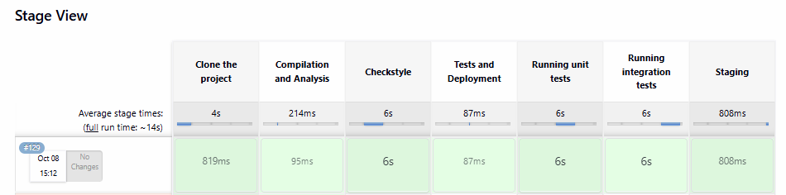
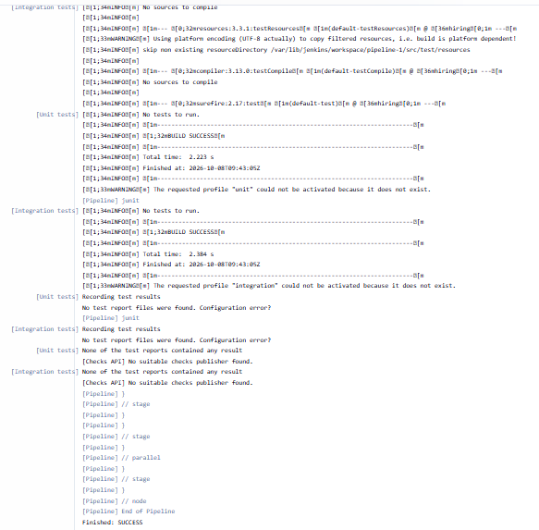
First, we’re cloning the repository from GitHub, then changing the directory to our project, which is called spring-jenkins-pipeline.
Next, we compiled the project and apply Checkstyle analysis in a parallel way.
The following step represents a parallel execution of unit tests and integration tests, then deployment of the app.
Parallelism is used to optimize the pipeline, and have the job runs faster. It’s a best practice in Jenkins to simultaneously run some independent actions that can take a lot of time.
For example, in a real-world project, we usually have a lot of unit and integration tests that can take longer.
Note that if any test failed the BUILD will be marked as FAILED too and the deployment will not occur.
Also, we’re using JENKINS_NODE_COOKIE to prevent immediate shut down of our application when the pipeline reaches the end.
You can find a more general script working on other systems in the source code.

6. Analysis Report
After creating the job, we’ll save our script and hit Build Now on the project home of our Jenkins dashboard.
Here’s an overview of the builds:
A little further down we’ll find the stage view of the pipeline, with the result of each stage:
Each output is accessible when hovering over a stage cell and clicking the Logs button to see the log messages printed in that step.
We can also find more details of the code analysis. Let’s click on the desired build from the Build History on the right menu and hit Checkstyle Warnings.
Here we see 60 high priority warnings browsable by clicking:

The Details tab displays pieces of information that highlight warnings and enable the developer to understand the causes behind them.
In the same way, the full test report is accessible by clicking on Test Result link. Let’s see the results of the com.baeldung package:
Here we can see each test file with its duration and status.

7. Conclusion
In this article, we set up a simple continuous delivery environment to run and show static code analysis and test report in Jenkins via a Pipeline job.
As always, the source code for this article can be found over on GitHub.

TASK-9 Simple Jenkins Pipeline with Marathon and Mesos

1. Introduction
In this article, we’ll be implementing a simple Continuous Delivery pipeline with Jenkins, Marathon and Mesos.
First, we will give a high-level overview of the technology stack and architecture, with an explanation of how everything fits together. Following that, we’ll move onto a practical, step by step example.
The outcome of this will be a fully automated Jenkins pipeline, deploying our application to our Mesos cluster using Marathon.

2. Overview of Technology Stack
When working with containers and microservice architectures, we face new operational problems that we wouldn’t have done with more traditional stacks.
For example, when deploying to a cluster, we have to deal with scaling, failover, networking and more. These difficult, distributed computing problems, can be solved with distributed kernels and schedulers, like Apache Mesos and Marathon.

2.1. Mesos
Mesos, in simplest terms, can be seen as the single server where our applications will be run. In reality, we have a cluster, but it’s this abstraction that makes it so useful.
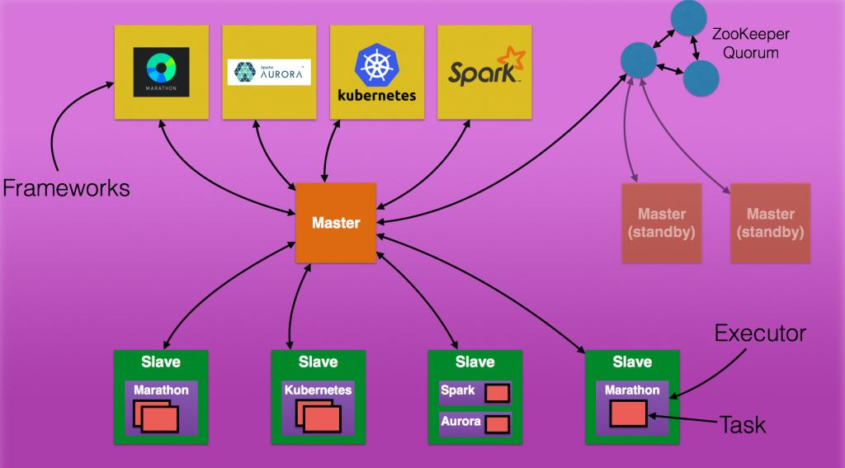

2.2. Marathon
Marathon is the framework which is used to deploy our applications to Mesos, solving difficult problems for us (health checking, auto-scaling, failover, monitoring etc).

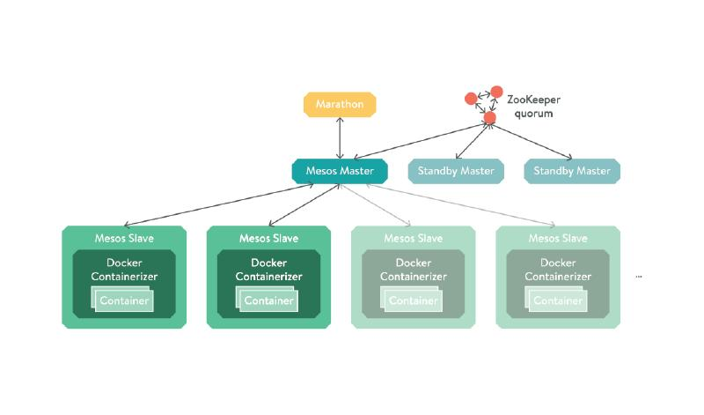

3. Setup and Installation
This article assumes you already have Jenkins, Mesos and Marathon running. If this is not the case, consult the official documentation for each of them to learn how to set them up. Without this, you won’t be able to implement any of the steps in the guide.

4. Our Delivery Pipeline
We shall be creating the following Jenkins pipeline:

There’s nothing particularly complex about this approach – it’s synonymous to the flow you of most modern CD pipelines. In our case, building will mean containerising the application, and deploying will mean using Marathon to schedule it on a Mesos cluster.

5. Testing and Building Our Application
The first step is to build and test our application. To keep things simple, the application we are going to be working with is a Spring Boot application. Because of this, our resulting artifact will be an executable jar. It won’t have any external dependencies other than the JRE, making it very simple to execute.

5.1. Creating Our Job
The first thing we want to do is create our Jenkins job. Let’s select “New Item” in the left-hand navigation bar, then select create a freestyle project, naming it “marathon-mesos-demo“:

5.2. Integrating With Git
Next, let’s configure it to clone the Github repository containing our application:

For the sake of simplicity, our repository is public, meaning that we are able to clone over https. If this wasn’t the case and we were cloning over SSH, there would be an additional step to set up an SSH user and private key, beyond the scope of this article.

5.3. Setting up Build Triggers
Next, let’s set up some build triggers so our job will poll git for new commits every minute:

5.4. Generating Our Build Script
We can now tell our job to execute a shell script when it runs. As we are working with a simple Spring Boot Maven project, all we need to do is run the command “mvn clean install“. This will run all the tests, and build our executable jar:
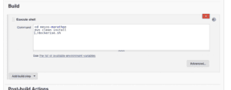

5.5. Building Our Project
Now we’ve set up the beginning of our pipeline, let’s trigger it manually by clicking “Build Now” on the job. Once the job is finished, we can confirm it has passed by it being marked as blue.

6. Containerizing Our Application
Let us move onto the next stage of our pipeline, which is packaging and publishing our application with Docker. We need to use Docker as containers are specifically what Marathon manages. This isn’t unreasonable, as virtually anything can run in a container. It’s easier for a tool like Marathon to work with the abstraction granted by these.

6.1. Creating the Dockerfile
First, let’s create a Dockerfile in the project root. Essentially, a Dockerfile is a file containing instructions to the Docker Deamon on how to build an image:
FROM openjdk:17-jdk-alpine
ADD target/mesos-marathon-0.0.1-SNAPSHOT.jar app.jar
EXPOSE 8082
ENTRYPOINT ["java","-jar","/app.jar"]Copy
The image we are building is simple – all it contains is an executable jar and a shell command which will execute it when the container starts. We also have to make sure that we are exposing the port that our application will listen on, in this case ‘8082’.

6.2. Publishing the Image
Now that we are able to build our image, let’s create a simple bash script which builds and publishes it to our private Docker Hub repository, and put it in our project root:
#!/usr/bin/env bash
set -e
docker login -u baeldung -p $DOCKER_PASSWORD
docker build -t baeldung/mesos-marathon-demo:$BUILD_NUMBER .
docker push baeldung/mesos-marathon-demo:$BUILD_NUMBER
Copy
You might need to push your image to the public docker registry or your private one.
The $BUILD_NUMBER environment variable is populated by Jenkins, incrementing with every build. Although slightly brittle, it is a quick way of getting each build to increase in version number. The $DOCKER_PASSWORD is also populated by Jenkins, and in this case, we will make use of the EnvInject plugin in order to keep it secret.
Whilst we could store this script directly in Jenkins, it’s better practice for it to remain in version control, as it can then be versioned and audited alongside the rest of our project.

6.3. Building and Publishing on Jenkins
Now let’s modify our Jenkins job so it runs “Dockerise.sh” after building the jar:
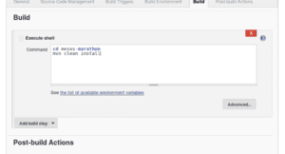
And then, let’s run our job to confirm again, confirming everything is working by it going blue.

7. Deploying Our Image
Our pipeline is nearly complete. There is only one more stage, which is to use Marathon to deploy our application to our Mesos cluster.
Jenkins comes with a “Deploy with Marathon” plugin. This acts as a wrapper around the Marathon API, making it easier than it would be when working with traditional shell scripting. You can install it via the plugin manager.

7.1. Creating Our Marathon.Json File
Before we can use the Marathon plugin, we need to create a “marathon.json” file, and store it in our project root. This is because the plugin is dependent on it.
This file: “marathon.json” contains a Mesos Application Definition. This is a description of a long-running service (application) that we want to run. Ultimately, the Jenkins Marathon plugin will POST the contents of the file to the Marathon /v2/apps endpoint. Marathon will then in turn schedule the defined application to run on Mesos:
{
"id": "mesos-marathon-demo",
"container": {
"type": "DOCKER",
"docker": {
"image": "",
"network": "BRIDGE",
"portMappings": [
{ "containerPort": 8082, "hostPort": 0 }
]
}
}
}
This is the simplest configuration we can give for a containerized application.
The property: “portMappings” needs to be set correctly in order to make our application accessible from our Mesos slave. It basically means, map the container port 8082, to a random port on the host (mesos slave) so we can talk to our application from the outside world. After deploying our application, Marathon will tell us what that port used.

7.2. Adding a Marathon Deployment Build Step
Let’s add a Marathon Deployment post build action to our job:

Notice we’re telling the plugin where Marathon is running, in this case ‘localhost:8081’. We’re also telling it the image we want to deploy. This is what the empty “image” field in our file get’s replaced with.
Now we’ve created the final stage of our pipeline, let’s run our job one more time and confirm that it’s still passing, this time with the extra step where it sends our application to Marathon.

7.3. Verifying Our Deployment in Marathon
Now it’s been deployed, let’s take a look in the Marathon UI:

As we can see, our application is now shown in the UI. In order to access it, we just need to check what host and port it has been assigned:
In this case, it’s been randomly allocated the port 31143 on localhost, which will internally map to port 8082 in our container as configured in the application definition. We can then visit this URL in our browser to confirm the application is being served correctly.

8. Conclusion
In this article, we’ve created a simple Continuous Delivery pipeline using Jenkins, Marathon, and Mesos. Whenever we push a change to our code, it will be running in an environment a few minutes later.
Later articles in this series will cover more advanced Marathon topics, such as application health checking, scaling, failover. Other use cases for Mesos, such as batch processing may also be covered.
The source code for our application is available over on GitHub.

